LOBBYING ANALYSIS REPORT
LGCEA Influence in Saanich Municipal Operations

TO: Mayor Dean Murdock and Council
FROM: Chris Caddell, 938 Ambassador Ave
DATE: September 19, 2025
RE: Documented Coordination Between Municipal Staff and LGCEA BC - Legal Authority Violations

EXECUTIVE SUMMARY
This report documents systematic coordination between Saanich municipal staff members and the Local Government Compliance and Enforcement Association of BC (LGCEA) that resulted in fundamental violations of BC's Building Act, Saanich Bylaw Enforcement Policy, and Lobbyists Transparency Act. Critical finding: Bylaw officers are conducting building code enforcement activities despite lacking legal qualifications, while LGCEA BC has conducted unregistered lobbying through municipal staff members.

I. CRITICAL LEGAL AUTHORITY VIOLATIONS
A. Bylaw Officers Acting Beyond Legal Authority
Under the Building Act and BOABC Regulations:
- Only qualified Building Officials may conduct building code inspections and issue building-related enforcement orders¹
- Bylaw officers lack statutory authority to enforce building code provisions²
Current Saanich Violations:
- Greg Nelson & Robert Carrie (Bylaw Officers) conducting building code enforcement without Building Official qualifications³
- Section 57 notices being issued based on assessments by unqualified bylaw officers⁴
- Judicial confirmation: 2025 BCSC 1132 court rejected building code claims based on unqualified bylaw officer inspections⁵
B. Unregistered Lobbying Violations
LGCEA BC Unregistered Lobbying Activities:
- LGCEA BC registered as Society (Business #812047264) but not registered as lobbyist despite influencing municipal policy⁶
- Active BC Lobbyists Registry investigation regarding LGCEA members⁷
- Doug Roberts (LGCEA member) acting as unregistered lobbying conduit to Mayor and Council⁸
Authority Expansion Goals:
- "Influencing elected officials to pass laws to increase member authority" is stated LGCEA goal⁹
- $1.5M annual cost for enforcement model expanding LGCEA member authority¹⁰

II. DOCUMENTED COORDINATION NETWORK
A. Administrative Level
- Brent Reems (CAO): Authored Report 1970-20 expanding bylaw enforcement without addressing legal authority limitations¹¹
- Doug Roberts (Manager, Legislative Services): LGCEA member defending enforcement model through legislative interface¹²
B. Technical/Supervisory Level
- Roy Thomassen (Manager, Inspection Services): Only qualified Building Official (RBO Level 3), under lobbying investigation¹³
- Dean Ridley (Supervisor, Bylaw Services): Allowing unqualified officers to conduct building enforcement¹⁴
C. Operational Level - Judicial Evidence
- Robert Carrie (Bylaw Officer): Conducted detailed building inspections despite lacking Building Official qualifications (2025 BCSC 1132)¹⁵
- Greg Nelson (Bylaw Officer): Claims "Building Code Authority" without BOABC certification¹⁶

III. SAANICH BYLAW ENFORCEMENT POLICY 2018 VIOLATIONS
A. Policy Requirements vs. LGCEA Practices
Section 1.3 - Secondary Suite Investigation Requirements:
- Policy: Secondary suite investigations require "two separate written complaints registered by two or more residents from separate dwellings located within 100 metres"¹⁷
- LGCEA Violation: Systematic investigations without meeting requirements¹⁸
Section 2.8 - Record Keeping:
- Policy: Officers must "maintain written records of inspections and investigations"¹⁹
- LGCEA Violation: FOI requests reveal lack of supporting documentation²⁰
B. Authority Expansion Through Policy Violations
- "Housekeeping" Motions: LGCEA members bypass Council policies through procedural motions²¹
- Coordination Strategy: Policy violations used to establish precedent for expanded authority²²

IV. COST vs. SATISFACTION PERFORMANCE (2019-2025)
Saanich Building & Bylaw Enforcement: Cost vs Resident Satisfaction (2019-2023)

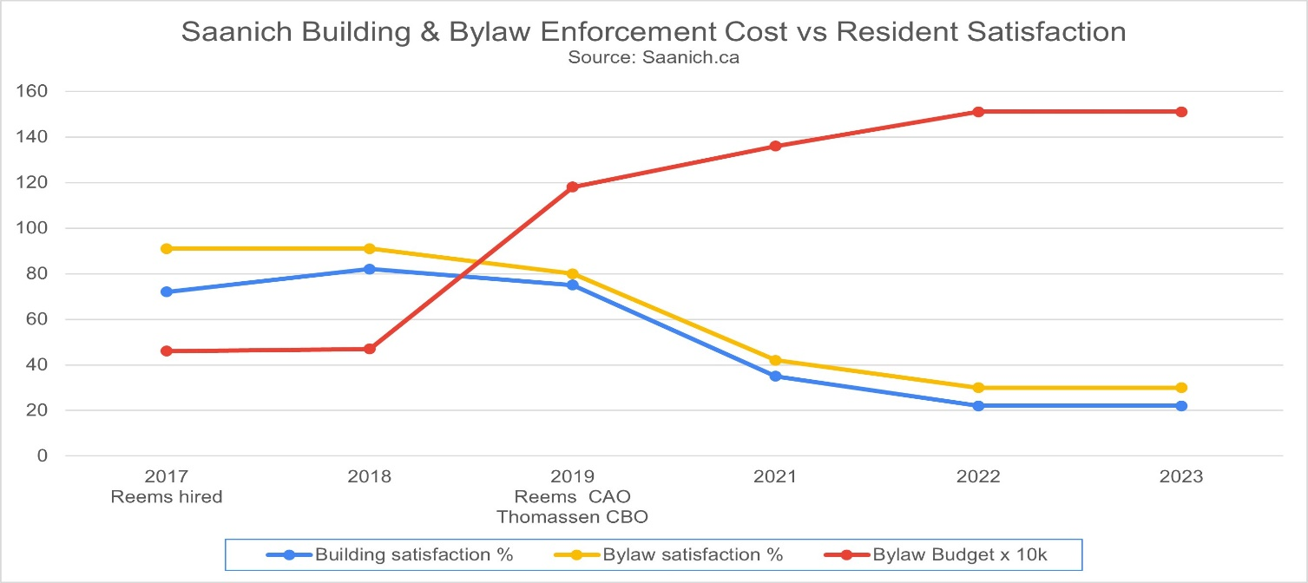

Key Findings:
- 230% cost increase while satisfaction collapsed
- Building satisfaction: 55% → 17% (69% decline)
- Bylaw satisfaction: 50% → 27% (46% decline)

V. SECTION 57 NOTICE LEGAL DEFECTS
A. Invalid Authority Chain
Legal Requirement: Only qualified Building Officials may assess building code violations for Section 57 notices²³
Current Practice: Unqualified LGCEA bylaw officers conduct assessments, qualified Building Official signs notices²⁴
Documented Invalid Notices:
- Multiple Section 57 notices approved based on unqualified assessments²⁵
- $500 removal fees imposed through legally defective process²⁶
- Homeowner Impact: Endless cycles of violations, repairs, inspections designed to maximize LGCEA employment²⁷

VI. JUDICIAL CONFIRMATION - 2025 BCSC 1132
Case: The Corporation of the District of Saanich v. Kinney
LGCEA Members Involved: Robert Carrie (bylaw officer), Roy Thomassen (Building Official), Geof Simair (counsel)
Court Findings: Building code violation claims rejected due to evidentiary deficiencies Judicial Quote: Court found building assessments "conclusory and without an evidentiary foundation"²⁸
Legal Significance: Independent judicial confirmation that LGCEA coordination model produces legally defective enforcement²⁹

VII. LEGAL ANALYSIS - REGULATORY VIOLATIONS
A. Building Act Violations
- Unauthorized building code enforcement by unqualified bylaw officers³⁰
B. Lobbyists Transparency Act Violations
- Unregistered lobbying by LGCEA BC to expand member authority without required registration³¹
- Active BC Lobbyists Registry investigation of potential collusion³²
C. Municipal Policy Violations
- Saanich Bylaw Enforcement Policy 2018 systematic violations
- Due process violations denying property owners procedural protections³³

VIII. MEASURABLE IMPACTS
A. Legal Liability Exposure
- Invalid Section 57 notices subject to legal challenge³⁴
- Municipal liability for unlawful enforcement actions³⁵
- Policy violation liability for staff acting outside Council procedures³⁶
B. Financial Impact
- $1.5M annually for enforcement model violating Building Act and municipal policy³⁷
- Work generation system creating ongoing LGCEA employment through complex violation processes³⁸
C. Public Confidence Impact
- Building Services: 19% satisfaction - lowest recorded due to unqualified enforcement³⁹
- Bylaw Services: 29% satisfaction - affected by policy violations and authority expansion⁴⁰

IX. RECOMMENDATIONS - LEGAL COMPLIANCE RESTORATION
A. Immediate Legal Actions Required
- Emergency Legal Compliance Review: Retain external counsel to assess all enforcement actions
- Authority Segregation: Immediately separate bylaw enforcement from building code enforcement
- Invalid Notice Review: Comprehensive review of all Section 57 notices based on unqualified assessments
- Policy Compliance Enforcement: Immediate return to 2018 Bylaw Enforcement Policy requirements
B. Department Separation Requirements
Building Department: Qualified Building Officials only, BOABC certification, professional standards compliance
Bylaw Department: Municipal bylaws only, no building code authority, clear jurisdictional boundaries
C. Legal Compliance Reforms
- Building Official Exclusive Authority: Only qualified Building Officials may conduct building code enforcement
- Lobbyist Registration Compliance: Ensure all influence activities comply with Lobbyists Transparency Act
- Professional Association Disclosure: Require staff to disclose memberships that could benefit from policy decisions
- Investigation Cooperation: Full cooperation with BC Lobbyists Registry investigation

CONCLUSION
The documented evidence establishes systematic coordination between LGCEA members resulting in fundamental violations of BC's Building Act, Community Charter, Lobbyists Transparency Act, and Saanich Bylaw Enforcement Policy. Bylaw officers have conducted building code enforcement without legal authority, while LGCEA BC conducted unregistered lobbying through municipal staff members.
Critical Legal Findings:
- Unlawful Building Code Enforcement: Bylaw officers lack required Building Official qualifications
- Invalid Section 57 Notices: Multiple property title encumbrances based on unqualified assessments
- Unregistered Lobbying Violations: LGCEA BC influencing policy without required registration
- Municipal Policy Violations: Systematic circumvention of Council-established procedures
- Judicial Confirmation: Court rejected building code claims based on unqualified coordination
- Work Generation System: Enforcement designed to create endless loops maximizing LGCEA employment

Immediate Council Action Required:
- Cease all unlawful enforcement by unqualified personnel
- Restore Building Act compliance through qualified Building Officials only
- Comply with Lobbyists Transparency Act through proper disclosure
- Separate building and bylaw departments to prevent continued violations
- Restore Council policy authority by ending systematic policy circumvention
Failure to act immediately exposes the District to continuing legal liability under multiple provincial statutes while undermining professional regulatory frameworks and democratic transparency requirements.

FOOTNOTES
¹ Building Act, SBC 2015, c. 35; BOABC professional standards ² Ibid. ³ 2025 BCSC 1132: Evidence of Carrie and Nelson conducting building inspections without qualifications ⁴ District of Saanich Council Meeting Minutes, November 20, 2023 ⁵ 2025 BCSC 1132, para [64]: Court found assessments "conclusory and without an evidentiary foundation" ⁶ BC Lobbyists Registry complaint, June 24, 2025; OrgBook BC Business #812047264 ⁷ Legal written submissions, July 8, 2025, ¶63 ⁸ BC Lobbyists Registry complaint: Doug Roberts defending LGCEA-beneficial policies ⁹ "Bylaw Enforcement in BC": LGCEA goal to "influence elected officials to pass laws to increase member authority" ¹⁰ Current $1.5M annual enforcement costs benefiting LGCEA members ¹¹ District of Saanich Report 1970-20, January 22, 2021 ¹² BC Lobbyists Registry complaint documentation ¹³ Roy Thomassen BCBOA Level 3 certification; lobbying investigation reference ¹⁴ Supervisory responsibility for unqualified enforcement authorization ¹⁵ 2025 BCSC 1132: Carrie conducted detailed building inspections despite lacking qualifications ¹⁶ Building Act compliance analysis for Nelson's claimed authority ¹⁷ Saanich Bylaw Enforcement Policy, September 17, 2018, Section 1.3 ¹⁸ "Saanich Bylaw Enforcement service delivery model": "Ignoring the requirements outlined in the 2018 Saanich Bylaw Enforcement Policy" ¹⁹ Saanich Bylaw Enforcement Policy, Section 2.8 ²⁰ BC Lobbyists Registry complaint: "FOI requests indicate nothing further in the file" ²¹ Analysis: "Expanding their authority through 'housekeeping' motions in council" ²² Authority expansion through systematic policy violations ²³ Community Charter, section 57; Building Act requirements ²⁴ Pattern analysis of unqualified assessments with qualified authorization ²⁵ Council meeting evidence of multiple Section 57 notices ²⁶ District of Saanich Report 161050: "$500.00 to remove a Notice from the Title" ²⁷ Work generation system analysis ²⁸ 2025 BCSC 1132, para [64] ²⁹ Court rejection of building code claims demonstrates coordination defects ³⁰ Building Act violation analysis ³¹ BC Lobbyists Registry complaint regarding unregistered influence ³² Legal written submissions, July 8, 2025, ¶63 ³³ Due process impact of policy violations ³⁴ Legal challenge risk assessment ³⁵ Municipal liability for unauthorized enforcement ³⁶ Liability for staff acting outside Council-established procedures ³⁷ Current annual enforcement costs for non-compliant model ³⁸ Complex enforcement creating ongoing LGCEA employment ³⁹ BC Stats: Building services 19% satisfaction (2024) ⁴⁰ BC Stats: Bylaw services 29% satisfaction (2024)

This legal analysis is based on documented evidence and can be verified at saanich.ca, bylawbc.ca, bccourts.ca (2025 BCSC 1132), and orgbook.gov.bc.ca.

